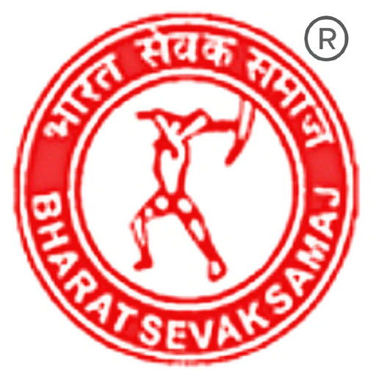
Authorized Training Center (ATC) Approval Application
Note: For School & Specialized Courses no need to mention individual course names in item 11 & 12 of the approval application.
They are package courses. Just fill the package name in the box. Like Computer College & School (or) Business Courses.
Please fill the form in CAPITAL LETTERS
Before filling up the application, please refer BSS terms & conditions and how to get approval.
Name of the Applicant
Name of the Institution
Institution Address
Telephone Number
Mobile Number
E-Mail Address
Applicant Residential Address with Telephone Number
Do you have own Building or Rental
Do you have any experience in the field of education & training? If yes, mention?
Name of the Courses {from our website 10 courses}
Details regarding Teaching Faculty:
Details regarding Class Rooms and Facilities:
Any other Relevant Information:
I hereby accept all the terms and conditions of BSS Correspondent Signature
Note: The following documents to be enclosed with application
- Demand Draft in favour of PRADESH BHARAT SEVAK SAMAJ, CHENNAI.
- Rs. 50/- Agreement plain bond (2 nos) with Institution name or Correspondent name for MOU Your building agreement, If Rental building, rental agreement.
- Photograph of infrastructure like Building, Class Room and Other Facilities Correspondent Photo 2 Nos, Address Proof. (Passport size)
- 10 Course list from our website. (www.bsseducation.org)
If necessary, use additional sheets for entering details.

